|  |
| --- |
| Internet of Things (IoT) |
| In the fourth industrial revolution, the demand for many advanced technologies has hicked, one of them is the “Internet of Things(IoT) ”. IoT is one of the very fascinating technologies around the globe. It is the rising technology, many engineers have already started their full-time careers as IoT developers, and this technology has the power to change the lifestyle, manufacturing industries, and businesses according to the standards of the fourth industrial revolution.  IoT technology is purely based on sensors and the data collected by the sensors. The microcontrollers or microprocessors can freely take decisions with the help of data collected by the sensors based on a given set of instructions. Also, there is a demand for AI and ML engineers in the IoT field. |
| FEBRUARY 10, 2022  Inderprastha Engineering College  Authored by: Harsh Talwar (IT 2A) |



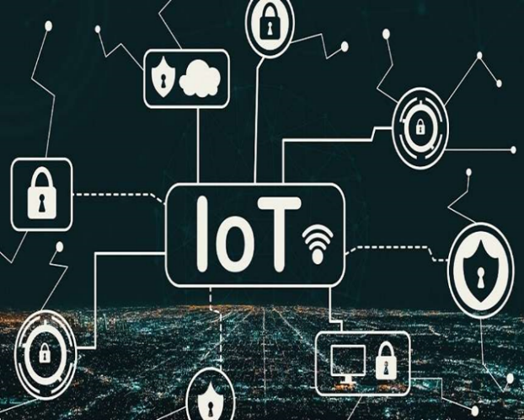

|  |
| --- |
| *“If you think that internet has changed your life, think again. The Internet of Things is about to change it all over again!”*  *-Brendan O’Brien*  *(American Record Producer)* |
| **Definition:**  IoT is essentially a platform where embedded devices are connected to the internet to collect and exchange data with each other. It enables devices to interact, collaborate and, learn from each other’s experiences just like humans do.  **History:**  The world’s first IoT device was invented in the early 1980s at Carnegie Melon University. A group of students from the university created a way to get their campus Coca-Cola vending machine to report on its contents through a network to save them the trek if the machine was out of Coke.  In 1990, John Romkey connected a toaster to the internet for the first time. A year later, a group of students at the University of Cambridge used a web camera to report on coffee. They came up with the idea to use the first web camera prototype to monitor the amount of coffee available in their computer labs coffee pot.  This is how IoT started its journey and now more than 75 billion devices are connected to the internet.  **Purpose:**  The goal behind the Internet of things is to have devices that self-report in real-time, improving efficiency and bringing important information to the surface more quickly than a system depending on human intervention.  **Some applications of IoT are as follows:**  **C:\Users\HP\Downloads\image 6.jpg**  **Smart City**  A Smart City is a futuristic city that is based on a renewable source of energy and fulfills all the energy needs on its own as its power consumption is higher than normal cities due to the use of many different types of sensors in many systems of Smart City.  The systems include “**Energy management system**”, “**Waste management system**”, “**Disaster management system**”, **Security management system**”, “**Sewage management system**”, “**Traffic management system**”, “**Water Management System**” and many more in the whole city.  *“Smart cities are those who manage their resources efficiently. Traffic, public services and disaster response should be operated intelligently in order to minimize costs, reduce carbon emissions and increase performance.”*  *-Eduardo Paes*  *(Mayor of Rio de Janeiro)*  The Smart City is the biggest mega project for any economy. The top economies in the world have very few Smart Cities. The top 7 Smart Cities are “New York”, “Singapore”, “London”, “Barcelona”, “Oslo”, “Toronto”, and “Tokyo” (source- [blog.bismart.com](https://blog.bismart.com/en/top-smart-cities-around-world)). Smart cities are clean, sustainable, secure, and self-sufficient. With these features, smart cities also generate employment for many workers, electricians, engineers for a long period and also generate permanent employment too.  C:\Users\HP\Downloads\img 4.png  In India, there are two smart cities that are under development namely “Gift City” and “Dholera Smart City”. If you want to know more about Gift City and Dholera Smart City can check the links below:  [giftgujarat.in](http://www.giftgujarat.in/genesis)  [dholerainfraproject.com](https://www.dholerainfraproject.com/dholera.html)  **Smart Cars**  A smart car is a technologically advanced next-generation concept car that is based on clean fuel, automated by computers having all the safety features and features like self-driving, automated parking, finding a lot for parking, advice drivers in semi-automatic mode, security of the car, driving without any person through GPS and many more.  *C:\Users\HP\Downloads\img 5.png*  *“If I were to look in the United States or in Europe, in some of the garages, you would have a Bentley or two Bentleys or a high-end Mercedes, and you may find a Smart also in that same garage because that person thinks it's a fun extra car to have. He may have four cars but also have a Smart because he thinks it is cute.”*  *— Ratan Tata*  *(Indian Industrialist)*  In the field of smart cars, it increased the demand for electrical, electronics, mechanical, and software engineers. These cars are mostly electrified and come with a variety of inbuilt sensors like **fuel meter sensors, ultrasonic sensors, gas sensors, an inertial sensor, pressure sensor, RADAR sensor, GPS, cameras, and many more** sensors to give full support to the driver and ensure full safety of passengers.  This technology is in its initial development or trial phase. Many luxurious car brands are working on this. To know more refer to the video link to see the variety of Smart Cars:  [https://www.youtube.com/watch?v=D-f0yVjYBRQ&t=575s](%20https:/www.youtube.com/watch?v=D-f0yVjYBRQ&t=575s)  **Smart Agriculture**  Agriculture is the most important sector for every economy especially for the countries like India and China which have the highest number of population feedings in the world. As agriculture is the most important sector it’s important to automate the processes in the agriculture sector.  *The best solution for this problem is* **“Smart Agriculture”** *or* ***“*Smart Greenhouse”**. Smart Agriculture or Smart Greenhouse is the IoT solution in which sensors will collect the data for every plant and deliver it to the microcontroller or microprocessor to automate the task like watering with the help of motors in a controlled manner.  C:\Users\HP\Downloads\img 3.png |

This solution will reduce production, energy, water, and labor losses and increase productivity. This solution will increase the employment of many engineers as well as botanists. This solution will require many types of sensors like temperature sensors, humidity sensors, water level sensors, and many more.

To know more about Smart Agriculture follow the below links:

[iotforall.com](https://www.iotforall.com/smart-farming-future-of-agriculture)

[cropin.com](https://www.cropin.com/smart-farming/)

Smart Wearables

Wearable technology is most popular in IoT applications and probably is one of the earliest industries to be developed the IoT at its service. Many companies like mi, boat, Fitbit, realme, etc. built some products like smartwatches, fitness trackers, tracking shoes, etc. are everywhere these days.

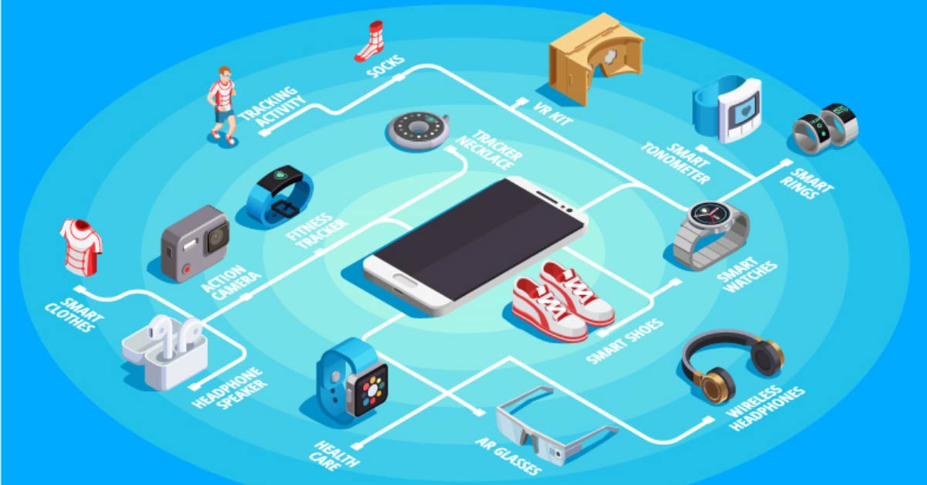

*“Wearable devices are here to stay, and they'll only get more sophisticated and effective as they evolve. Until now, most of us have made our health and fitness decisions based on what we think we know about ourselves. Advancements in technology - wearables and otherwise - will eventually take much of the guess work out of healthy living.”*

*-Michael Dell*

*(CEO of Dell Technologies)*

There are many types of smart wearables which are easily accessible in the market and still growing. The motive of this industry is to make our belonging wearables into smart wearables like a ring, wristwatches, clothes, shoes, glasses, cameras, speakers, headphones, brushes, etc.

This industry has great demand for Engineers as well as chip designers, chip manufacturers, and health experts in designing the product according to give health information.

This is a really big industry to know more follow the links below:

[gadgetsnow.com](https://www.gadgetsnow.com/slideshows/8-smart-wearables-you-must-know-about/photolist/51256562.cms)

[thegadgetflow.com](https://thegadgetflow.com/blog/10-smart-wearables-you-need-in-your-life/)

Industrial Automation

The fourth industrial revolution is directly addressed towards industrial automation. In industrial automation, the motive is to automate the manufacturing process to reduce labor cost and production cost, increase manufacturing, and reduce production time and cost.

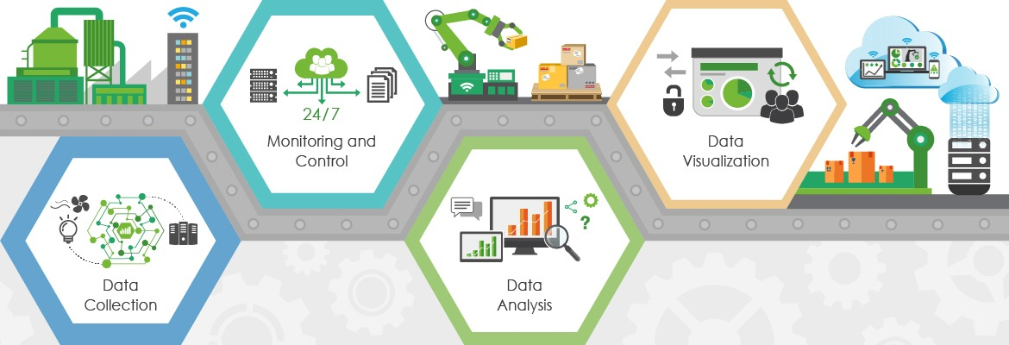

To achieve this motive industries automate manufacturing with the help of many different types of robots, computers, sensors, machines, and different types of management systems.

In India, the most automated industry is the automobile industry with very little human interruption. All work like welding and painting is done by robots which are to be applied to other industries.

*“The first rule of any technology used in a business is that automation applied to an efficient operation will magnify the efficiency. The second is that automation applied to an inefficient operation will magnify the inefficiency.”*

*-Bill Gates*

*(American Business Magnate)*

The various management systems which make an industry automate and come under IoT include “monitoring and control system”, “Data collection”, “Data analysis”, “Data visualization”, “Temperature control”, “packaging control”, and many more.

If you want to know more about industry automation you can refer to the links given below:-

[electricaltechnology.org](https://www.electricaltechnology.org/2015/09/what-is-industrial-automation.html)

[electrical4u.com](https://www.electrical4u.com/industrial-automation/)

Smart Home Applications

From the quote “Charity begins at home” if we want to build smart applications of IoT then we should start from home. In a country like India where a definite amount of people are struggling for their homes, it is strange for thinking of a smart home, but in technologically advanced countries many people have fully advanced smart homes. But, In India, there are many smart home applications available in the market like Alexa, Hey Google!, etc.

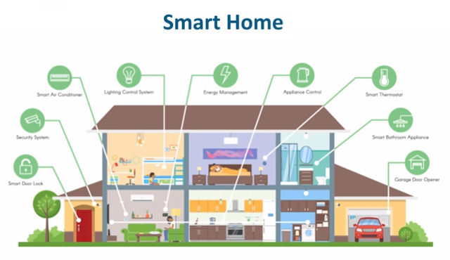

The best example I can think of here is Jarvis, the AI home automation employed by Mark Zuckerberg. There is also Allen Pan’s home automation system where functions in the house are actuated by the use of a string of musical notes.

Check out the video links to know more about Mark Zuckerberg and Allen Pan’s Home Automation below:-

­­­­­­­­

[https://www.youtube.com/watch?v=u­­­­­­_­­v4enoaZ1o](https://www.youtube.com/watch?v=u_v4enoaZ1o)

<https://www.youtube.com/watch?v=glZnkpIDWSE>

[“Nest is one vertical implementation of a set of smart products for the home. But we will support other peoples smart products for the home.”](https://www.youtube.com/watch?v=glZnkpIDWSE)

[-Sundar Pichai](https://www.youtube.com/watch?v=glZnkpIDWSE)

[(CEO of Alphabet and Google)](https://www.youtube.com/watch?v=glZnkpIDWSE)

There are is a great demand for AI and ML engineers in this field in designing and architecture of AI model of IoT other than those engineers who have great support in every IoT application.

There are very several systems that are used in smart homes are “smart door lock”, “security surveillance”, “Thermal control unit”, “Energy management”, “Water management”, many more.

If you want to know more about smart home automation you can refer to the link given below:-

[internetofthingsagenda.techtarget.com](https://internetofthingsagenda.techtarget.com/definition/smart-home-or-building)

IoT In Healthcare

IoT applications can turn reactive medical based

systems into proactive wellness-based systems.

The resources that current medical research uses, lack critical real-world information. It mostly uses leftover data, controlled environments, and volunteers for medical examination. IoT opens ways to a sea of valuable data through analysis of real-time field data and testing.

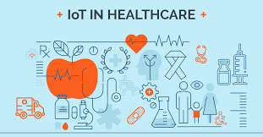

*“By enabling edge computing, critical data can be transmitted from the ambulance to the real time, saving time and arming emergency department teams with the knowledge they need to save lives.”*

*-Weisong Shi*

*(Professor of computer science, Wayne State University)*

IoT has to change the whole medical system to convert hospitals and ambulances into smart hospitals and smart ambulances. Many devices are available in the medical field that converts the healthcare industry technologically advanced, but creating a full automated healthcare system is not there.

The medical system has already adapted towards IoT devices like “Remote patient monitoring”, “Glucose monitoring”, “Heart-rate monitoring”, “Hand hygiene monitoring”, “Depression and mood monitoring”, “Parkinson’s disease monitoring”, “Connected inhalers”, “Ingestible sensors”, “Connected contact lenses”, “Robotic surgery”, and many more.

This is still starting IoT has a lot more to give to the medical industry to know more follow the links below:-

[insights.omnia-health.com](https://insights.omnia-health.com/technology/iot-future-healthcare)

[zenbusiness.com](https://www.zenbusiness.com/blog/future-of-iot-in-healthcare/)

IoT Neural Network

*“The Internet of things will augment your brain”*

*– Eric Schmidt*

*(American Businessman)*

From the above context, it is meant that IoT has the power to augment the human brain. It is possible only because of IoT. This is not a normal phenomenon, it’s the new emerging technology named “Neural Network”. In this technology, electrodes are connected directly or indirectly with the brain and read the brain instructions and perform automated results.

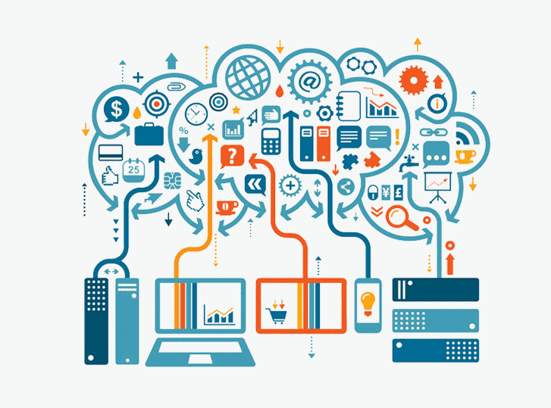

This field is not been more explored. This field is in its initial phase and companies like Neuralink is working to explore more in this field. This is a very vast field and has its applications too.

Some applications of Neural networks are as follows:

* Neural networks are often directed at researching, mapping, assisting, augmenting, or repairing human cognitive or sensory-motor functions.
* Neural networks may replace lost functions, such as speaking or moving.
* Neural networks may restore the ability to control the body, such as by stimulating nerves or muscles that move the hand.
* Neural networks have also been used to improve functions, such as training users to improve the remaining function of damaged pathways required to grasp.
* Neural networks can also enhance function, like warning a sleepy driver to wake up.
* Neural networks might supplement the body’s natural outputs, such as through a third hand.

These are some applications but the Neural Network field is much vaster than that. If you want to know more about this field follow the links below:-

[Investopedia.com](https://www.investopedia.com/terms/n/neuralnetwork.asp#:~:text=A%20neural%20network%20is%20a,organic%20or%20artificial%20in%20nature.)

[Ibm.com](https://www.ibm.com/cloud/learn/neural-networks)

Conclusion

These are only some applications but IoT is a vast field. This Emerging Technology has the potential to change the world with numerous applications. Not just industries this field can boost up all the sectors of the Economy. There are some future predictions that by 2025 total number of IoT devices is expected to grow to 75 billion according to Statista Research Department or 80 billion according to IDC.

*“As the Internet of Things advances, the very notion of a clear dividing line between reality and virtual reality becomes blurred, sometimes in creative ways.”*

*-Geoff Mulgan*

*(Professor at University of London)*

According to Statista, the IoT industry will grow to around 1.6 trillion by 2025. This industry will not only employ IoT developers or software developers but generate employment for other sectors of engineering also like Electrical and Electronics, and Mechanical Engineers.

This sector will also generate employment for “Internet Providers”, “Cloud Service Providers”, “Cloud Engineers”, “Sensors and Transponder Manufacturers”, “PCB Designers and Manufacturers”, and “Semiconductor Industry”.

If you liked the blog and want to learn and see the practical

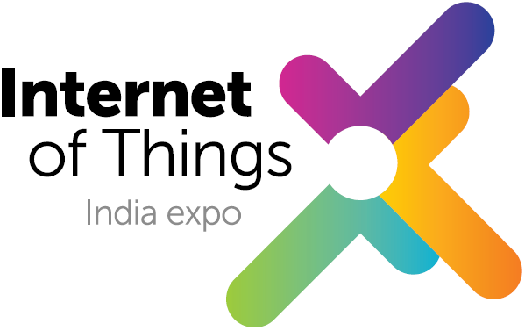implementation of IoT products and services, I have good news for you there will be 3 days live IoT India Expo 2022 in Pragati Maidan, New Delhi, Delhi-110020 on 23rd,24th, and 25th March 2022.

Exited! GET REGISTERED with the link given below:-

[iotindiaexpo.com/register-now](https://www.iotindiaexpo.com/register-now.aspx)

To know more visit - [iotindiaexpo.com](https://www.iotindiaexpo.com/)